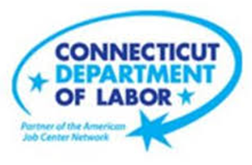

**NEW WEEKLY JOB POSTINGS FROM   
HELP WANTED ONLINE  
Office of Research**

**Week Ending April 22nd, 2023: Total New Ads Shift Up 11% Over The Week.**WETHERSFIELD, April 28th, 2023 – During the week ending April 22nd, 2023, there were 8,410 new postings, up 819 new ads or +11% over the week. This over-the-week 11% increase continues total ad count volatility that began in March. From early March to the week ending April 22nd, over the week change has ranged from -22% to +52%. The graph below illustrates the pronounced week-to-week shifts. Amid this top line volatility, most industries saw their share of total ads stay relatively consistent over those 8 weeks. Two industries that have seen large share shifts are Retail Trade and Manufacturing. In early March those two industries respectively were 9% and 8% of total ads. By the week ending April 22nd, they were 12% and 11% respectively. Employers in Retail Trade that have had the largest increases over that time include Chico’s, Macy’s, BJ’s Wholesale Clubs, and Walgreens. Within Manufacturing, most of the industry Increase from early March to present is due to job ad increases at Raytheon.  
  
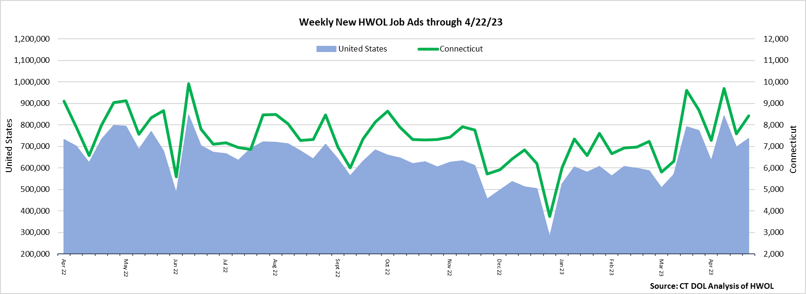  
 **Industries** with the most new postings include Health Care & Social Assistance, Retail Trade, and Manufacturing.

**Occupations** with the most new postings include Registered Nurses, Retail Salespersons, and Supervisors of Retail Sales Workers.

**Employers** with the most new postings include Raytheon, Yale-New Haven Health System, and Humana.

**The three industries with the most new job postings were:**

* **Health Care & Social Assistance** (1,822 new postings, +11% over the week)
* **Retail Trade** (1,029 new postings, +19% over the week)
* **Manufacturing** (902 new postings, +41% over the week)

   
 During the week ending April 22nd, 12 of 21 industries had over-the-week increases. Most of the overall 819 new ad increase across all industries occurred in Manufacturing (+263 new ads), Health Care & Social Assitance (+178 new ads), and Retail Trade (+161 new ads). The employers with the largest increases within three respective industries were Raytheon (+334 new ads), Yale-New Haven Health System (+139 new ads), and Chico’s (+45 new ads). The 12 increasing industries grew by a combined 982 new ads. The 9 industries with over the week decreases fell by a combined 163 new ads and the largest industry decrease occurred within Accommodation & Food Services (-82 new ads). The largest employer decrease within Accommodation & Food Services was Dunkin’ (-27 new ads).   
  
  
 For more information on total job ads by industry for Connecticut and its labor market areas, see the monthly report available here: <https://www1.ctdol.state.ct.us/lmi/hwol.asp>

**New Job Postings by Occupation** 

**The occupations with the most new postings were:**

* Registered Nurses ( 455 new postings, +17% over the week)
* Retail Salespersons (388 new postings, +34% over the week)
* Supervisors of Retail Sales Workers (235 new postings, +1% over the week)

**Employers with the Most New Job Postings** Employers with the most new job postings during the week ending April 15th, were mostly within Health Care & Social Assistance, Retail Trade, and Finance & Insurance. The employers with the most new ads in these three respective industries were Yale-New Haven Health System (205 new ads), Walgreens (67 new ads), and Raytheon (398 new ads). Overall, the 25 employers with the most ads account for a combined 26 percent of total new ads. Among the 25 employers shown above, 22 increased over the week and 3 decreased.   
  
**What is HWOL?**The **Conference Board Help Wanted Online**® Data Series (HWOL) measures the number of new, first-time Online job postings and jobs reposted from the previous month for over 16,000 Internet job boards, corporate boards, and smaller job sites that serve niche markets and smaller geographic areas. To view more HWOL data, go to: <https://www1.ctdol.state.ct.us/lmi/hwol.asp>